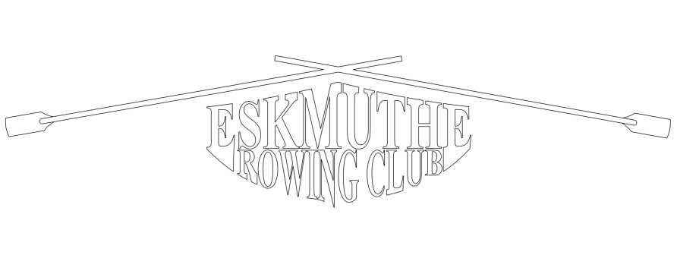
MEMBERSHIP APPLICATION FORM
Eskmuthe Rowing Club was set up to build, row and race St Ayles skiffs and is open to the entire community. Eskmuthe R.C. is a member of the Scottish Coastal Rowing Association.
New Member ☐ Full Membership ☐
Renewal ☐ Unwaged* ☐

Full membership is £30. Unwaged membership is £20. *We are a community club so if these amounts will restrict you from joining please speak to one of the committee.

Personal Details
Name
Address
Telephone
Email
Date of Birth

Medical Information
Please detail any important medical information that you feel we should be aware of:

Emergency Contact Details
Provide contact details for someone we may contact in event of an emergency:
Name
Telephone
Relationship

Declaration
I agree to abide by the constitution & code of conduct of Eskmuthe Rowing Club a copy of which is available in the members area of the website - https://www.eskmutherowingclub.org.uk/members-documents.html.
I give consent for my details to be stored and used by Eskmuthe Rowing Club. We will store your data securely and only use it to get in touch with you directly with relevant and up-to-date information.

Name
Date

Please email this form to eskmuthe@gmail.com. Payment preferably by bank transfer to - Sort code 80 22 60 Account number – 10742262 or by cash to the committee or the cox of your next row.

